

# CAR RENTAL WEBSITE

AS A PROJECT WORK FOR THE COURSE

## INTERNET PROGRAMING LABORATORY (CSE 326)

**NAME: GAUTHAM KRISHNA**

**SUBMITTED TO: MIR JUNAID RASOOL**

**REGISTRATION NUMBER: 12207283**

**DATE OF SUBMISSION:05/12/22**

**ROLL NUMBER:13**

**SEMESTER:** FIRST SEMESTER

**SCHOOL OF COMPUTER SCIENCE AND ENGINEERING LOVELY PROFESSIONAL UNIVERSITY, JALANDHAR, PUNJAB, INDIA.**

**DECLARATION**

I GAUTHAM KRISHNAReg No.**12207283** herebydeclare that the project work reported entitled "**CAR RENTAL SERVICE**” in partial fulfilment of the requirement for the award of Degree for Bachelors of Technology in CSE at Lovely Professional University, Phagwara, Punjab is an authentic work carried out under supervision of my supervisor MR. Mir Junaid Rasool. The content of this project represents authentic and honest effort conducted, in its entirety, by me. I am fully responsible for the contents of my project work.

Student Name: GAUTHAM KRISHNARegistration Number: **12207283**

# INTRODUCTION:

**Objective of the project:**

The car rental project that our group have developed enables customers to rent cars in major cities and places such as Visakhapatnam, Bangalore, Hyderabad, Kolkata, Darjeeling etc. This website makes it possible on getting the customers the best possible car hire deals. With this website’s secure search and booking engine customers can compare the best possible prices across places and brands

**Description of the project:**

The website primarily welcomes you with a number of links such as login, sign up, manage booking, popular destinations etc. One can login to their existing account at the main page to make bookings. If he/she does not have an account, we have given them the facility to register themselves and create a new account there itself. In manage booking section the website asks for customers email address and reservation number to proceed, in case the user forgets the reservation number we have also made the arrangements for retrieving their respective reservation number. Scrolling down the main page we can see the options to search for cars. The basic information such as pickup location, pickup date, drop off location, drop off date along with some other fields are the required fields that need to be filled up so as to continue the search. At the bottom of the webpage the option for managing booking and for contacting us are given. This summarizes the main description about our project “Car rental system”.

**Scope of the project:**

The project “Car rental system” have immense scope in the future as the tourism sector all over the countries are increasing. Therefore, a website that enables customers to choose the best rental prices will be inevitable in the near future. Today even though we do have many websites for hiring vehicles no one assures the customer that they get the best price possible for them, so that’s where the scope of our project lies. The car rental industry is growing very fast and demand for this industry has increased globally in the past few years. The global car rental industry looks good and seems so many opportunities for this sector in the future. With the increase of national and international tourists in different countries, the industry is expecting more growth and bright car rental business opportunities.

# SYSTEM DESCRIPTION:

# We did this web site project by using different tags of HTML , CSS . This a Web sites which helps us to rent a car and helps to easily access the rental car services in different places in India . This also helps us in making a safe trip to popular locations . We even made a page for customer care service which helps customer to contact team for queries

# 3.0 DESIGN:

## HTML CODE:

## 1)

## 

## 2)

**CSS CODE:**

1)

2)

RESULTS:

**1)**

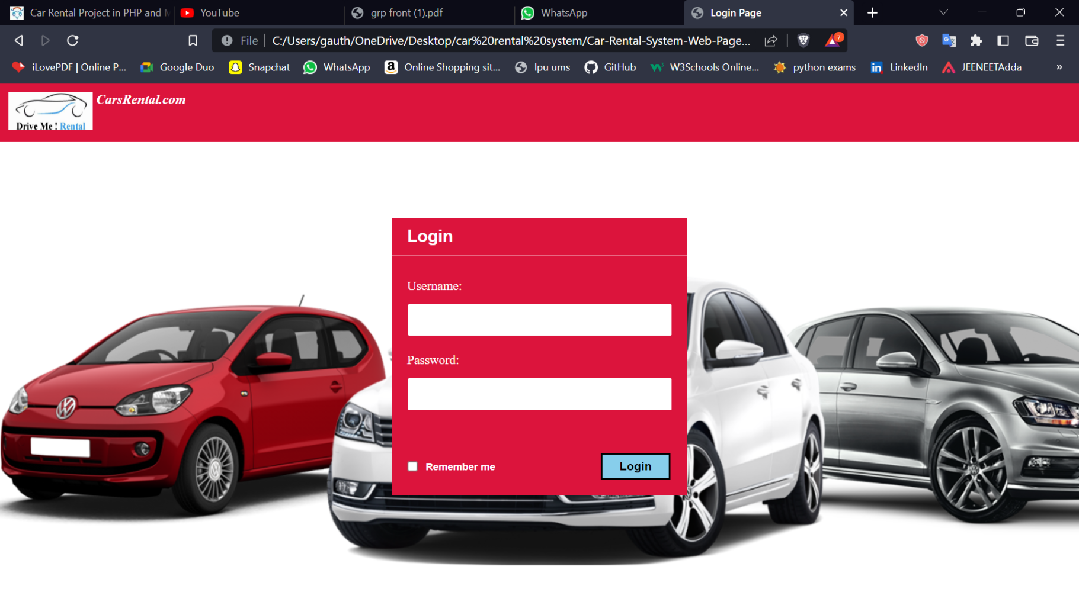

**2)**

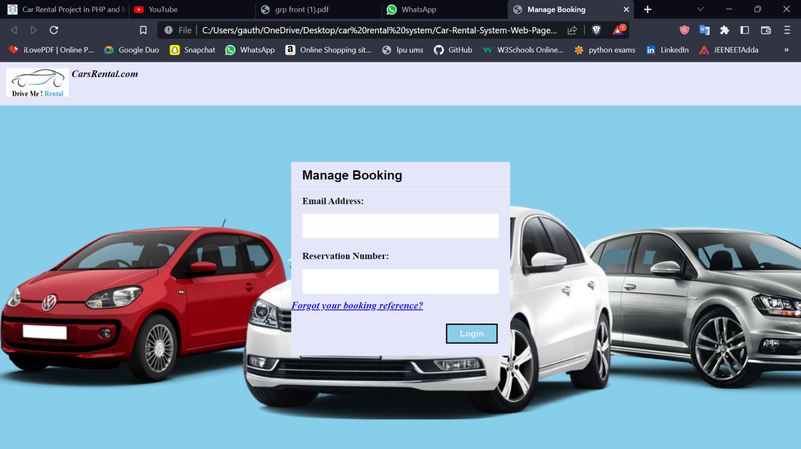

**4.0 FUTURE WORK:**

The car rental industry is growing very fast and demand for this industry has increased globally in the past few years. The global car rental industry looks good and seems so many opportunities for this sector in the future. With the increase of national and international tourists in different countries, the industry is expecting more growth and bright car rental business opportunities. Considering these opportunities, we plan on making the website more user friendly as possible and also incorporate as much as car rental companies as possible. By doing this we can make sure that we can fulfil the promises that we make to our customers.

THANKS